**COMP1202 - Programming 1**

**Coursework 2**

**Name: BRANDON TING WEE KANG**

**Student ID: 33399085**

**Choice: B. Food Ordering System**

**Part 1. Relations Tree**

**Draw a simple tree that shows the relation between the classes. The diagram must show the class type (abstract or concrete), and the relationship type (implements, extends, or composed of).**

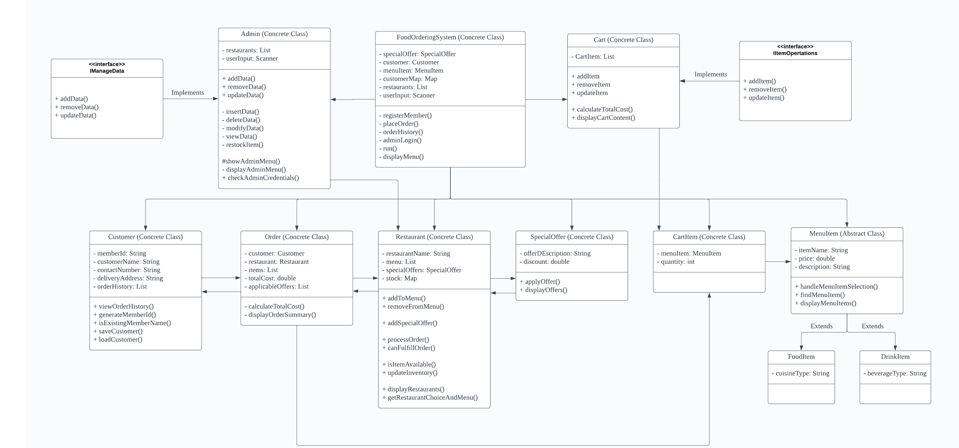

**Part 4. Storytelling**

**1. What problems did you encounter during the development of this coursework; what makes you stuck for many hours trying to figure out what's wrong.**

*During the construction of this course, many problems occurred in managing user input, testing and debugging, and data administration. Using a command line interface to interact with users presented challenges that required careful consideration of various input choices and strong error handling. It took a while to test and debug, especially when figuring out how different components interacted. Effective data management requires careful evaluation of data formats and storage methods, including inventory and order history. These difficulties created obstacles that took a lot of time to overcome, and the best answers made software development education a thorough experience.*

**2. How did you manage to solve the problems.**

*Addressing these issues required the implementation of systematic solutions. I created comprehensive input validation and error-handling systems to deal with user input problems, using loops and conditionals to instruct users and ensure proper inputs. Debugging complexity was reduced by using debugging tools to go through the code and discover errors, which was supplemented by the development of unit tests for functions and components, allowing for early identification of errors. I chose relevant data structures, such as lists and maps, for effective data management. I explored data persistence alternatives, adapting decisions to the project's requirements while prioritising data consistency and integrity. These solutions expedited the development process and contributed to the project's success.*

**3. What are the things that you are proud of about your program; imagine this is a business pitching session.**

*I am proud of my program's data management capabilities. The administrator portions have complete control, allowing them to easily add, remove, amend, and inspect restaurant and menu data. This tool enables administrators to curate the platform's offers more effectively. Customers also benefit from a seamless and user-friendly interface and the ease of examining their whole purchase history. This dual capability improves the overall user experience and highlights the program's expertise in data administration, promoting it as a dependable and adaptable option for both administrators and consumers.*